## Mrs. Southern 9th Grade Honors Literature

Remind: Specific to class period: text ***ONE*** of the following @bbs1st, @bbs2nd, @bbs5th, or @bbs6th to 81010

Email: [bsouthern@paulding.k12.ga.us](mailto:bsouthern@paulding.k12.ga.us)

Canvas: Be sure to favorite our class.

**Course Overview**   
This course will expose students to complex literary and informational texts to provide rigor and relevance to the advanced eighth grade student. Because this is an honors class, students will be challenged and their skills in reading, writing, listening, speaking, and viewing will be assessed throughout the year with more in-depth reading and writing assignments.

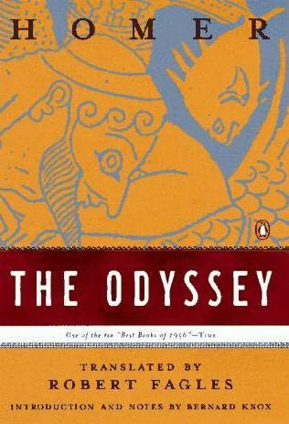**Extended Texts**

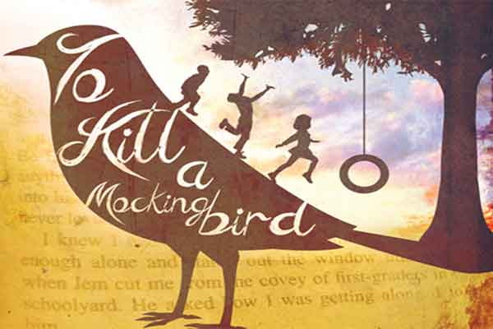 

**Pacing**  
Because of the rigor and pace of this advanced ELA class, students are expected to demonstrate independence and initiative in completing each assignment. Teachers are available for extra help during pre-scheduled tutoring times which are available on Mondays and Wednesdays.

**Classroom Assessment**

Summative Assessments (unit tests, projects, performance tasks): 71%  
Formative Assessments (quizzes, classwork, homework, checkpoint tasks): 29%   
  
**Standardized Assessment**  
9th grade Literature and Composition EOC Milestone (May). (Please note: the EOC assessment may be subject to change for 20-21 school year.)

**High School Credit**  
Students will receive .5 Carnegie units of high school credit for each semester. Final course average grade will be posted to their high school transcripts and will affect their high school GPA.

**Student Responsibilities and Goals:**

1. **Reading** – Students must keep up with assigned readings and independent reading in an analytical manner. Students are expected to annotate each text that they read, and all work should be kept in their 5-subject spiral notebook.
2. **Writing**: Students are expected to express ideas through writing in an effective and cohesive manner. Writing is a skill: the more you write, the better you become, and the clearer your voice will emerge.
3. **Discussion**: Students must participate in sharing personal insights, explorations and interpretations of the literature with classmates in a productive manner.

**Class Expectations**  
This is a high school honors class, and the work is rigorous. Students are expected to stay on track with all assignments and there will often be work done outside of class. This work (usually reading and annotating text) will prepare the student for the next day’s discussion. Failure to keep up with outside assignments and reading will be detrimental to performance in class, so be sure to use a planner or agenda to stay on top of assignments.

**Bring your own Technology**

There will be many times throughout the year that students will be encouraged to use their own technology to further the learning objectives in class. During these times, it is expected that students closely adhere to the BYOT policy.

* Only students with a signed consent form will be able to use technology in class.
* The following infractions will cause a loss of an individual’s technology privileges.
  + Using personal technology at any time other than the assigned time.
  + Using personal technology for social reasons (texting, any blocked social sites, i.e. Facebook, Twitter, etc.)
  + Connecting the personal technology outside of the school’s WIFI site

**Canvas**

We will utilize the technology of the Canvas web site during the year for various units of study. Discussion questions, polls, and other interactive postings will be assigned, and students will be notified if they are expected to respond. This is a great way of taking the discussion to a higher level of thinking, and it helps students hone their technology grammar, as all responses are expected to adhere to standard English rules. Please be sure to sign up for notifications through Canvas, as messages will be sent through both Canvas and Remind this year.

**Remind 101**

In addition to Canvas, I encourage students and parents to sign up for the Remind text reminders. This is a great way for me to send out short notes to remind students/parents of important events, deadlines, and due dates. Additionally, Remind allows users to send messages to the teacher. Because these alerts come to my phone, it is often easier to send a quick message/question this way. All numbers are private, so no one can see my number as I send it, nor am I able to see the numbers of anyone on my list. **Please note that Remind 101 is set up per class period**, so to sign up for my Remind 101 alerts, text @bbs1st, @bbs2nd, @bbs5th, or @bbs6th to 81010.

|  |  |
| --- | --- |
| **Make-up Work Policy** | **Late Work Policy** |
| Students should complete assignments within a number of days equal to the length of the absence. For example, a student will have two days after returning to school to make up work missed during a two-day absence. It is the student’s responsibility to complete and turn in make-up work. | Students are expected to adhere to deadlines and due dates for assignments. Homework and classroom assignments will not be accepted after the due date unless arrangements are made with the teacher in advance. Summative assessments will be accepted with a 10-point penalty for each day past the due date. |

**Essential Supply List for All Grades and Classes**

School lockers will not be available for student use to begin the 2020-2021 school year. We have reduced the suggested supply list to include only essential supplies needed for school each day. All students will be allowed to store and carry their supplies in their own backpacks, and they should bring all essential items with them each day. Students will not be allowed to store any items in classrooms or other areas of the building. By ensuring that your student has the essential items listed below, we can reduce the need for students to share supplies. We will evaluate the need for issuing lockers to students at a later time.

Essential Supply List for **All** Grades and Classes

1 Backpack

1 Refillable Water Bottle (water fountains will be used as refill stations only)

1, 3-inch Binder OR 2, 1.5-inch Binders

Tab Dividers (with pockets if available)

Lined Notebook Paper for Binder

2 Composition Notebooks

Pencil box or pouch to store items

Pencils

Small personal, covered pencil sharpener

Pens

Highlighters

Markers and/or Colored Pencils

Glue Stick

Scissors

Hand-held pencil sharpener

1 USB or “Jump” Drive (optional but highly recommended)

6th Grade Students Only – Basic 4 Function Calculator

7th and 8th Grade Students Only – TI-30XS Multiview Scientific Calculator OR TI-36X Pro Scientific Calculator

**\*\*\*SPECIFIC FOR HONORS LITERATURE CLASS:**

***Five*** Subject Spiral Notebook (students will use this all year so it should not be used for other classes)

*The above syllabus is subject to change in order to accommodate classes that need additional or less time on a unit. Classes will be notified when changes are made to syllabus.*